**Jalen Powell**

**Bio 103**

**Lab J Exercises**

* **Understanding Heredity. Determining Genotypes and Phenotypes Using Coin Tosses**

**Ex. 1:**

1. **Complete the table below based upon two heterozygous parents. Record the genotypes and phenotypes of the results.**

**2. Determine the expected genotypes and phenotypes for the Punnett Square.**

**Genotypes:____1:2:1_______________**

**Phenotypes:_____3:1_____________**

|  |  |  |
| --- | --- | --- |
|  | **H** | **h** |
| **H** | HH | Hh |
| **h** | Hh | hh |

1. **Using the expected genotypes and phenotypes, predict the probability** of **genotype and phenotype combinations for 100 coin tosses. Record this information in the expected genotype column in the table A below and the expected phenotype column in table B.**
2. **Place two pennies in your hand, and then toss them onto a tabletop. Tally the letter combinations ( H= Heads; h= Tails) below, and record your results in the observed genotype and phenotype columns in Tables A & B**

**Table A Table B**

|  |  |  |  |  |  |  |
| --- | --- | --- | --- | --- | --- | --- |
|  | **Expected Genotype** | **Observed Genotype** |  |  | **Expected Phenotype** | **Observed Phenotype** |
| **HH** | **25%** | **37%** |  | **Heads** | **75%** | **90%** |
| **Hh, hH** | **50%** | **53%** |  | **Tails** | **25%** | **10%** |
| **hh** | **25%** | **10%** |  |  |  |  |
|  |  |  |  |  |  |  |

* **What did the pennies represent in the exercise? Were they an accurate representation? Why or why not? Why were two coins used?**
* The pennies were used to make the alleles and randomize the genotypes and phenotypes. It might not be the most accurate but the design of it works because of the pairings of heads and tails. The two coins were used as the two parents.
* **What is a Punnett square?**
* The Punnett square is a square diagram that is used to predict the genotypes of a particular cross or breeding experiment.

**Ex. 2:**

A trait is a specific characteristic of an organism. Traits can be determined by genes or the environment, or more commonly by interactions between them. As we have learned, the genetic contribution to a trait is called the genotype. The outward expression of the genotype is called the phenotype.

Trait is a specific characteristic of an individual. For example, their hair color or their blood type. Traits are determined by genes, and also, they are determined by the interaction with the environment with genes. And remember that genes are the messages in our DNA that define individual characteristics. So, the trait is the manifestation of the product of a gene that is coded for by the DNA. The word "phenotype" is sometimes used interchangeably with the word trait, and "phenotype" may also define a whole compendium of traits together.

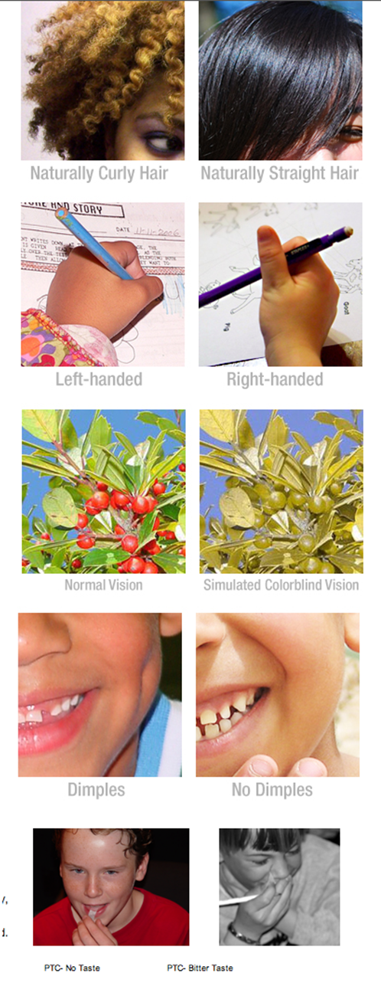Take a look at some common genetic characteristics:

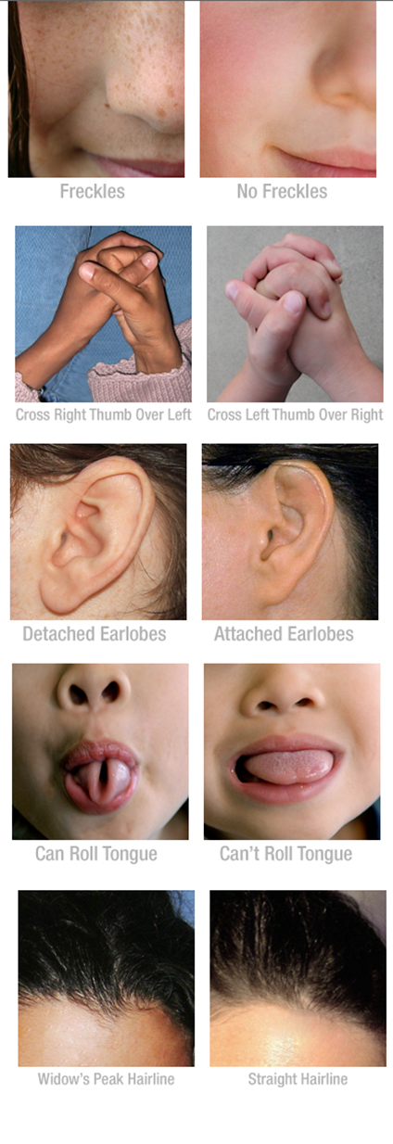

**In your kit you will find a small vial labeled “PTC Paper”. Inside you will find several small sheets of paper. Take a piece and give it a taste! Do you taste anything at all? Give a piece to a family member or a friend, can they taste anything?**

**Choose a few of the traits listed and gather trait information from as many relatives or friends as you can (safely!)**

**Based on your observations, which of these traits do you think are recessive?**

**Which are dominant?**

* On my dad’s side, grey hair is a very dominant trait among my dad and his brothers. A recessive gene on my mom side is height because my mom and grandma aren’t the tallest.

**Describe three autosomal dominant conditions in humans:**

* Some autosomal dominant traits that individuals may be familiar with are neourofibromitosis Type I, Huntington disease, and Marfan syndrome.

**Describe three autosomal recessive conditions in human:**

* Examples of autosomal recessive disorders include cystic fibrosis, sickle cell anemia, and Tay-Sachs disease.